A Rebellion Dogs Blog

July 2019

Transition in Stewardship

Founders, followers, flounderers
Since 2012, Rebellion Dogs has brought to light some interesting recovery ideas along with the challenges and turmoil facing AA. This includes divergent factions in AA, each of whom feel their view of AA is what’s best for AA; and those others—they’re closedminded and dangerous to newcomers and AA’s future. Today, we ask if our more liberal and conservative extremes, each eyeing the other with suspicion, aren’t nourishing AA instead of tearing us apart. Body temperature requires homeostasis mechanisms to maintain balance when we get cold or warm. Let’s see if Twelve Step/Twelve Tradition societies suffer from, or thrive on, equal and opposite forces.
Another June raps up; another Founders Day: June 10, the earmarked symbol that would mark, Bill W helping Dr Bob to get sober and in so doing, saving himself from the craving of drink, as well. That infamous June of 1935 was 84 years ago now. We enter our 85th year as Alcoholics Anonymous which caps off with the Motor City (Detroit) quinquennial self-congratulator gathering, June of 2020. I expect I’ll be there.
We will look back. We call the pioneers of AA, “founders.” Dead now, we tip our hat to founders, recognizing the efficacy of their leadership. Simply stated, the fellowship they left behind, remains, today. Bill W, in his self-effacing way, referred to himself at public appearances as a co-flounderer. This dismissive language got a laugh but also fended off efforts of others to put him on a pedestal.
When I was a small-business person, mentors said to me, “The quality of your leadership can be best measured by how well your business runs when you’re not there to run it.” That sounds smart and snappy; if it’s true, Bob and Bill are gone and we can look at their roles as leaders, or founders. Stewardship of AA is forevermore in the hands of AA followers, not our founders. Googling “pioneers” and “followers” online, we will see that qualities and personality traits of leaders and followers differ from each other. How does the AA leadership of us followers, differ from the days of all the “big trouble” being brought to the attention of AA pioneers? AA’s cultural makeup matured, from two or three fledgling groups, to groups with a few pamphlets and a book. Rules were added, these same rules would be revoked, Traditions later protected members and groups from rules and subordination.
The style that the founders left the fellowship to us in is called cultural determinism. A tendency, as a society ages is a longing for cultural imposition.
We’ll look at the differences, their relative merits and ponder what may serve AA best. Keep in mind, is our role as stewards to preserve AA exactly as it was in the 1940s? Is our duty to better prepare AA for the newcomer still to come? Are these approaches oppositional? Or does this yin vs. yang create homeostasis, or an equilibrium that makes us stronger?
AA was a teenager in years and Dr. Bob was dying with Cancer. Before succumbing to illness in November of 1950, Bill and Bob talked about turning AA over to the membership; what would look like and what guidance might be available to lean on in times of real (or seeming) crisis? Jimmy B was an early AA archivist and history-speaker. He recalled how the old-timers learned to get out of the way and leave the operations of AA to the two-to-five-year (sober) members. Here’s a bit from Bill W in New York, writing to Rosa and Jimmy B., who lived in San Diego, August 23, 1949:
“What you say is not surprising for we oldtimers, nearly all of us, are getting frightfully stale. I know that’s very true of me. I have worked far too long in the trouble department of AA. Anybody who does enough of that will finally go sour or crack up entirely. It is so everywhere. The oldtimers situation is getting to be a real problem. In a sense, it means we all have to start over again and get back to first principles. I am glad to see at the group and intergroup levels that our service affairs are in the hands of two to five year old people. Moreover, these folks wer not so badly burned as we oldsters. As a class they are not so screwy.”
“The spirit of rotation” was learned from experience in Alcoholics Anonymous. There are pamphlets, Grapevine articles and Twelve Tradition essays about these very issues. Rotating leadership (service) is now part of 12-Step/12-Tradition ethos.
But… you’re waiting for a but, aren’t you?
A leaderless society is not without risk. Pioneers have a higher risk tolerance than their followers. Vision is a key motivator to pioneers; fear—fear of change, as an example—is a key motivator for followers. Innovators, certainly AA founders, are not proprietorial – imitators and adaptors don’t threaten or offend leaders. Here is just such an example.
The first edition of Alcoholics Anonymous was a big red book. Another visionary, Ed W wrote The Little Red Book a study guide to the Big (red) Book. There was no conference to approve or disapprove such new initiatives when the Little Red Book was written; there was an idea of group conscience but certainly no Traditions or Concepts of World Service. This Little Red Book was still shared around with and by some members, when I came around in the 1970s. I hear it quoted and see it passed around less today, but it’s still around. Hazelden currently publishes it. It’s grown into a franchise by those devoted to it. Bill P wrote a study guide (to the study guide) in 1998. Karen Casey and (another) Bill W in 2004 wrote, The Little Red Book For Women.
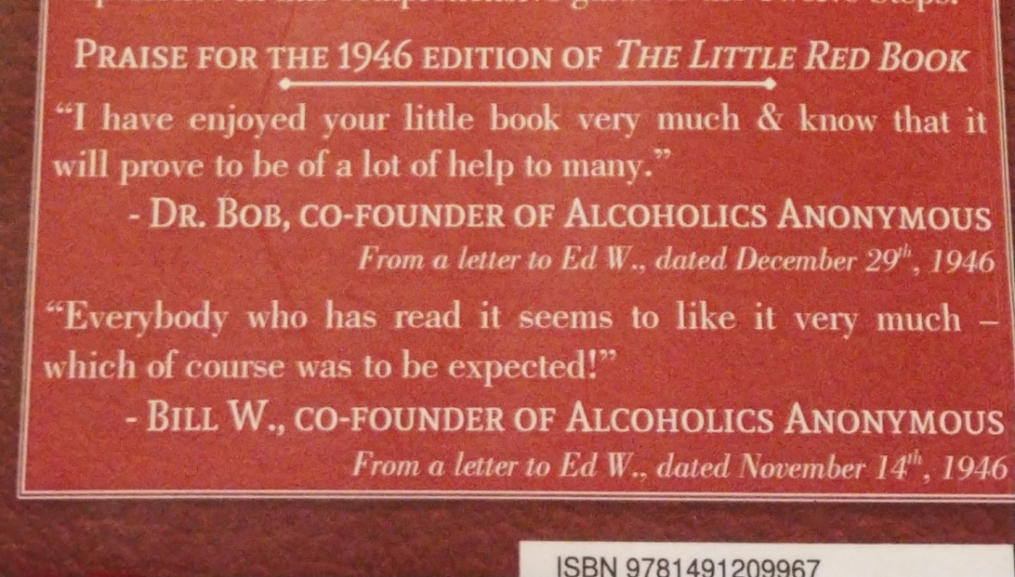
How were such things handled and what was felt about these unsanctioned side projects by the stakeholders (the royalty recipients) of our Big Book? Here’s what Bob and Bill had to say about this new “kid on the block,” The Little Red Book
Bill W November 1946: “Everybody who has read it seems to like it very much—which of course was to be exptected!”
Dr. Bob December 1946: “I have enjoyed your little book very much and know that it will prove to be a lot of help to many.”
Pioneers, for the most part, welcome more pioneering. While followers might be more inclined to reify work, cannonize founders and dismiss new approaches, founders are hungry for better outcome rates and new ways of doing things. The importance of the cause and not the credit is what motivates many inovators. Ed had identified a need, whereby some might want a more cohesive Step by Step narrative—for it’s day. Pioneer Bill showed no inclination to supress Ed’s efforts. Bob and Bill never said, “Nice book; but it has no place in an AA meeting!” or “Don’t call it AA.”
Written accounts reveal Bill W’s concern for the suffering alcoholics, that we failed to ssatisfy in the AA of the day. Why would he be insulted or threatedend by Ed, and presumably others? In fact, maybe Bill was inspired by Ed. Some time after Ed’s book, Bill’s Twelve Steps and Twelve Traditions (1953), was published. At the time, the Twelve Traditions was what Bill really wanted to advance but who would buy, read, or pass around a book about Twelve Traditions? It wouldn’t be a best-seller.
When was the last Traditions meeting you attended? Anyone out there: have you been to even one Twelve Tradition meeting in the last month? It’s been more than a month for me.
How much of Bill’s thought process to start the book off with essays on the Steps was informed by the warm reception enjoyed by The Little Book? We only know what Bill wrote, “Everybody who has read it seems to like it very much—which of course was to be exptected!”
Now, this idea of turning any fellowship over to the members is a visionary’s idea, that’s for sure. Is it the right thing to do and if it is, what are shortcomings we need to look out for?
Let’s go back to the business comparison. The head of a capitalist concen doesn’t turn the power over to the employees. Instead, leaders find another visionary to take over the reins. The new visionary doesn’t follow the first leader’s rule book; they forge a new path. Over years and decades a company is led by a succession of visionaries. The rank and file employees make slight adjustment to the leader as she or he adapts to, or anticipates, a changing marketplace.
What if Henry Ford turned his car company over to the employees?
Ford may have been honored for his nonconformindy, maybe even been cannonized. The date he first combined automobiles with assembly-line production, might be celebrated by employees, worldwide, every five years. And… the with a follower’s tendency towards preservation, Ford Motor Company might still be exclusively making and selling Model T’s.
“Don’t fix it if it ain’t broke!” the Ford group-think of today would assert. “We’re going to preserve the legacy of Ford, whose work was inspired by the hand of God.”
Followers don’t have vision—not to the extent that pioneers do. Pioneers aim is on a moving target. Followers see a still image. This is some of what caused organizational reification. Bill W would continue asking how can we alter or improve. We who followed, cast his message into an enduring—and unyeilding—monument.
An enterprise run by its followers:
"If it ain't broke, don’t fix it?"
Circa: 1953… Bob S has died and AA’s General Service Confernece (GSC) is three years old. The Fellowship is indeed in the hands of the next generation. Bill W and other early adpaters are onhand, when called upon. But the voting delegates, trustees and staff willl carry the day.
Context: AA was nearly 6,000 groups attended by 128,000 AA members in ‘53—twice the members and three times the groups since five years prior. With growth comes promise… along with alarm and growing pains.
To the 75 delegates from USA and Canada, Bill opened the Third GSC with “We are standing on the treshold of maturity… No one can say in truth that we are really mature yet. This process of maturing will go on as long as we last.”
The GSC would consider 40 new suggestions, Twelve Steps and Twelve Traditions, was hot off the press and conference attendees had business to deal with including new trustees, Grapevine, other literature and financial issues. One of two hotter issues of the day that Bill was asked to address was about variations of the Steps and Traditions among members and groups.
AA members of the day weren’t adhering the the Twelve Steps exactly as written. Some Swedish groups had a Seven Step AA alternative, adapted by a sister fellowship inspired by both The Oxford Group and early AA called, The Link Movement. Their Seven Points, as one variation of AA’s Twelve Steps, formed one example, discussed at the 1953 General Servce Conference. We will go into them in slightly more detail, later in this discussion.
Buddhists took the word “God” out of AA’s Twelve Steps and used “Good.” Seafearing AAs preferred a Six Step program in meetings held on vessles and at dock.
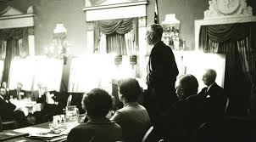
Hot off the AA press:
Our Great Responsibility – Rediscovering Wisdom from A.A.’s Co-founder is all of Bill’s General Service Conference talks from 1950 to 1970
The followers—now in charge of AA—were concerned; what was AA to do? How were we to get these nonconformists in line? Bill was asked to speak. A sumary of Bill W’s imprompu comments has been recorded in Conference Highlights: Special Report for the Groups on the THIRD GENERAL SERVICE CONFERENCE of A.A. You can read the report HERE.
In August 2018, we discussed Bill’s talk on Variations on AA’s Twelve Steps and Traditions, at AA Beyond Belief (Click here: https://www.aabeyondbelief.org)
Now, with the recordings of Bill’s conference talks transcribed, we can hear exactly from the founders mouth, “on the question of whether this program of ours is frozen as solid as an ice cube or whether there is any elasticity in it or not: whether we are going to get into the business of insisting upon conformity, whether we are going to get into the business of creating an authority that says that these Steps and Tradtions have to be this way” in agenda item: Variations in Form of the Twelve Steps and Twelve Traditions. Here are some segments from AAWS’s newest conference approved Bill W collection—in his own words:
- “And then, rather gingerly in the old days, because so many were in fear of being God-bitten, we would sort of sneak it up on the boys that, well, you can't really make this program stick in the experience of most of us anyway, unless you depend on some Higher Power—call it God if you wish, call it the group if you wish, but it won't work very well without that.”

- “[before the Traditions] a lot of the membership rules that the group had was to force conformity to those Twelve Steps. In other words, it would be rules like this: to be an A.A. member you must have done all the Twelve Steps, or you must agree with the Twelve Steps. Well, of course, long experience now tells us that there shouldn’t be any ‘musts’ in A.A. In fact, happily, the original suggestion was a suggestion only: twelve suggested Steps. So today we say, ‘Well, this sums up our experience and the more you do with these, the better off you’re going to be.” But folks, its minced, apple or plum: it’s up to you, really.”

- “It amazes me how in distant lands this same pioneering story is being reenacted. Some years ago the Twelve Steps came to the attention of a Swede… he takes a look at this program and he thinks that we don’t need twelve steps. His idea was that you needed only seven. So in Sweden today, they have seven steps. Do you think that we should write these Swedes and say you can’t belong to Alcoholics Anonymous unless you print those Twelve Seps the way we got them? No! They are merely going through the old pioneering process that we went through.”

- “There is one of these Traditions that really guarantees every A.A. group the absolute right to violate all of them if they wish to. We say here, ‘Each group should be autonomous except in matters affecting other groups or A.A. as a whole.’ And you must remember that these are suggested Traditions. When we say each group is autonomous, that means in effect that it has a right to be wrong from the viewpoint of the rest of you. My feeling is that the more we insist on strict conformity with these Steps and Traditions, the more resistance against them we create.”

- “And if any improvements are to come, who knows: We may get them from anyone.”
This wasn’t the only controversy Bill was asked to speak about:
On Interracial [AA]: “The sole question is this: How can each locality, from the point of view of its own customs, afford a better opportunity for colored people to get well? The big thing each us needs to remember concerning this phase of our program is the respect that one section of A.A. ought to accord to the other in the view they hold locally.”
At the time, AA culture wasn’t so different than the rest of 1950’s North America. Discussion on race and AA ranged from excitement in D.C. over the success of their “colored group”. One southern delegate said that the “colored people” in his state “weren’t alcoholics” and the topic shouldn’t be on the agenda. In the Midwest a delegate referred to Chippewan Indians suggesting “they aren’t typical alcoholics”.
There is much of our past—and present—that calls for inventory and reconciliation in our AA society.
Revisiting the 1953 GSC reveals hostility or worry deeply felt by AA followers. They showed concern or distain for adaptation of AA, even though it was their fellow AA members making these changes. What is widening the gateway to one is a chaotic existential threat to another.
Yes, there is a difference between innovators and adherents. Bill W wasn’t blind to this and he adapted AA to this reality. As a guard against censorship or banning individualism, Traditions protect members and groups from rules. We members point fingers at those others who violated this Tradition or that one—as if Traditions are rules. Traditions are our collective experience. They are designed to guide members, not bind us. Furthermore, Bill W reinforced every members’ rights in the Twelve Concepts for World Service. Warranty Six (Concept XII) reaffirms:
“… the extraordinary liberties which the A.A. Traditions accord to the individual member and to [their] group: no penalty to be inflicted for nonconformity to A.A. principles; no fees or dues to be levied—voluntary contributions only; no member to be expelled from A.A.—membership always the choice of the individual; each A.A. group to conduct its internal affairs as it wishes—it being merely requested to abstain from acts that might injure A.A. as a whole; and finally that any group of alcoholics gathered together for sobriety may call themselves an A.A. group provided that, as a group, they have no other purpose or affiliation…”
Have you ever seen a celebrity speak directly or indirectly about their AA membership publicly? Were they excommunicated from their home group? Of course not. They might take some shit from fellow members, but their seat is still waiting at the home group, and they still get one vote in business meetings, just as always.
Cultural determinism vs. cultural imposition:
A Rockstar who talks about working his 12-Step program on the late-night talk show is an example of cultural determinism. The AA group sets its own rules, anonymity might be one of them; the member follows or ignores the rules. Twelve Traditions and the Warranties makes room for different applications of AA coexisting in the same AA; Live and Let Live is the societal style is called cultural determinism: each group, being a unique culture that is shaped primarily by the ideas and values of their members, defines its primary purpose. And each member can reject what they like or embrace what they like. Central offices can and have rallies to oust a bad-apple group in the name of AA purity but that comes with unintended consequences. Generally, the ousted group is reinstated – if it wants to be—and sometimes the hostility towards the group attracts attention, and in some cases, more support. Cultural imposition—setting rules or governing groups—rarely lasts and AA tends to correct back to cultural determinism.
Groups are asked to be considerate of neighboring groups and AA-as-a-whole. But even if you or I worry that our neighboring group’s overly liberal or overly conservative approach will be the ruin of AA, we live and let live. Back in 1953 we see Bill engaged the conference delegates with the question, “whether we are going to get into the business of insisting on conformity, whether we are going to get into the business of creation an authority.” By design, so far, AA has no mechanism for excommunicating groups (or members) for being unpopular and/or non-compliant.
So, everything should be good between our AA groups, right? We all have all the autonomy we want; why would we care what others are doing in that group, right over there?
The Spring 2019 Box 4-5-9 (linked below), reveals that today, we see these 1953-esque squabbles continue to be wrestled with. In one case, local backlash was directed at a group who voted 40 out of 40 members to end their Lords Prayer closing ritual. Other local groups—feeling as if they had AA Traditions on their side—told the other home group, “to get out of AA if the don’t like God.”
Rescinding group autonomy, intimidation, the tyranny of the majority, these are expressions of cultural imposition.
Racism, sexism, other discrimination, exploitation and abuse happen in AA, all ranging on the bad-AA-0-meter from microaggressions in the 2-4 out of ten in the bad-AA-0-meter to harassment and discrimination in the 7-9 out of ten bad-AA-0-meter range. AA groups are informed by, and a reflection of, the community just outside the meeting doors. Here is an example of underrepresented populations in AA suffering the same systemic discrimination we hear about throughout society.
From the Spring 2019 Box 4-5-9 on a discussion about Inclusivity:
“Garrett closed by saying that serious problems remained, however, and while he believed that A.A. was capable of becoming more welcoming, it had not happened yet.
Fast forward to 2019, and there have been only eight black trustees in A.A.’s 80-year history. And, though the number of black delegates to the General Service Conference has been increasing, many African Americans, among other groups, can still feel excluded or set apart in A.A.
While it may seem an intractable challenge that has remained with A.A. for its entire lifespan, there are, if not solutions, steps that can be taken to ensure that the hand of A.A. continues reaching out to anyone, anywhere.”
In 1953 AA invited Bill to weigh in on two topics: Should we limit group autonomy in terms of how each group conducts itself and can we bend or impose rules on groups or AA-as-a-whole to overcome racism and/or other discrimination. The fight for cultural imposition vs. cultural determinism (for the good of AA) has always been a question for the AA followers that have been AA stewards for most of our history. The General Service Office doesn’t have the power to impose rules nor the will to mediate local skirmishes. Bill’s idea of an egalitarian AA was—as we see it today—not a list of rules in which to conduct our meeting, dictated by AA World Services, Rather, 120,000 sets of meeting rules are currently being talked about by 120,000 home groups. 120,000 is the number of AA groups and that’s how many lists of rules there are. The only rules upon a group are rules we set for ourselves through group conscience.
Bill Wilson wasn’t phased by a tendency towards reification. Who’s seen this excerpt from a 1961 letter from Bill to a member?
“As time passes, our book literature has a tendency for conversion into something like dogma, a human trait I am afraid we can do little about. We may as well face the fact that AA will always have its traditionalists, its fundamentalists and its relativists.”
Is AA held back by a constant struggle between more liberal factions and more conservative factions, each demanding that everyone saves time and sees it their way? It is possible to me, that while counterintuitive, AA’s polarity might be held together instead of held back in terms of what contributes to strength and longevity for AA.

Homeostasis – more AA Yin begets more AA Yang
From the East: Wikipedia describes the strength and harmony that opposition fosters in the Chinese philosophical idea of yin and yang which, “is a concept of dualism in ancient Chinese philosophy, describing how seemingly opposite or contrary forces may actually be complementary, interconnected, and interdependent in the natural world, and how they may give rise to each other as they interrelate to one another.”
From the West: The idea of Homeostasis isn’t as old, going back to 1865 France, and Dictionary.com describes “the tendency of a system, especially the physiological system of higher animals, to maintain internal stability, owing to the coordinated response of its parts to any situation or stimulus that would tend to disturb its normal condition or function.”
I might be bending a physiological principle here or a philosophical word there to make a point here about how our 12-Step culture depends on divergent views. In nature, as in AA, seemingly opposing pressures maybe both complementary and interdependent.
Bill W said that we best face “the fact that AA will always have its traditionalists, its fundamentalists and its relativists.” Fundamentalists feel that AA, or in some cases, their brand of AA is the only winning formula in the fight against alcoholism. Traditionalists may take chapter and verse from the book Alcoholics Anonymous literally and see “the” purpose of AA as following the Big Book as an instruction manual, exactly as written. Relativists say this kind of dogma is a turn off to forward thinkers and we’d be more effective applying flexibility in our practice of AA, maybe the wording, too.
In Homeostasis, our outer body temperature gets too cold and we shiver to warm up our core. When we have a fever, we sweat to cool off. It could be that more Back to Basics AA inspires the forming of more Freethinkers/Secular AA groups and vise-versa whereby we, “maintain internal stability, owing to the coordinated response of [AAs] parts to any situation or stimulus that would tend to disturb its normal condition or function.”
Take-what-you-like-and-leave-the-rest is a way of the relativist. Our adaptation of pliable principles is limited only by our own imagination. Here’s just a few approaches to Steps in 12-Step meetings:
- A LGBTTIQQ2S+ group (or conference or other AA gathering) adapts AA’s Steps to rewrite “God as we understood Him,” replacing Him with a non-binary gendered higher power.
- A mostly Islamic AA groups replaces “God” with “Allah.”
- “Goddess” is used in place of “Him” in a women’s group.
- One atheist/agnostic group never reads or posts any AA Steps.
- Another atheist/agnostic group rewrites and reads their own secular version of AA’s Steps.
AA relativists are protected by embedded cultural determinism. These adapting Yin groups may never have started if the heat had not been turned up by a fundamentalist Yang group beating their drum about “exactly as written in the Big Book.”
Of course, many special purpose groups that are making a safe-space open to serve a specific demographic (gender, sexual orientation, age, minority religion, non-religious) may read the steps exactly as written in the Big Book. Why couldn’t they be both traditionalists and gateway wideners? This is cultural determinism, too; one group of underrepresented AAs doesn’t have to do as other same-spirited groups do—not all young people groups or secular groups or women’s groups have to march in lockstep with each other. Some take a relativist approach, others like a traditional meeting format and let the individuality express itself in the group discussion. One group may symbolize their identity by customizing AA language to better include themselves. But for some special purpose groups, 1939 language has no oppressive power over them, changing the words to a new—but just as codified—wording isn’t a meaningful way of asserting their AA freedoms.
The 1953 Conference questioned the wisdom of turning a blind eye to nonconformity in AA. An example that Delegates looked at were some Swedish seven-point program groups that dared to call themselves AA:
- You must admit, that you are an alcoholic.
- You must believe in a power which is greater than your own.
- You must change your outlook on life.
- Undertake a thorough investigation of your moral concepts.
- Discuss those affairs of yours which are unsatisfactory, and acknowledge your faults and shortcomings with another person.
- Settle issues with all persons with whom you have unsatisfactory relations.
- When you have come away from the alcohol, and you have, if you work on following these points, then you have experienced something which you can not thank any individual human being for. You must express your thanks through helping other alcoholics, and that is the only thing we demand of you.
Is that Seven-point program the same principles as Americans expressed in the 1939 Twelve Steps?
If you say “yes” maybe you’re a relativist.
If you were at the 1953 Conference and you feel the Seven Steps are a bastardization of AA, maybe you’re a traditionalist. Maybe being informed by the proliferation of such groups would disturb and motivate you to go back to your home group and bring up a motion in your group’s business meeting to “only read from conference approved literature,” to avoid this kind of liberalism that might reshape your meeting.
There exists today Ten Step AA groups, secular Step and no-Step reading groups. We have Back to Basic groups that feel the Big Book is AA’s only legitimate message and other Back to Basics groups that read the Wally P guide to Alcoholics Anonymous. We have groups of atheists that consider themselves spiritual and groups of atheists that will tell you that AA recovery is practical—not supernatural. We have groups that don’t pray and “our more religious” spiritual—not religious groups that pray at the start, middle and end of the meeting.
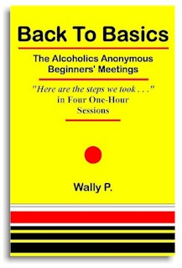
So even inside the traditionalist, fundamentalist and relativist tribes, Yin voices pull Yang chains and resentment + coffeepot = a new AA meeting—diverging forces aid in the growth and diversity of AA-as-a-whole. Thinking about Yin/Yang, Homeostasis or as Newton would say, “For every action, there is an equal and opposite reaction (Third Law of Motion),” through this new pair of Homeostasis glasses, let’s look at any of these positions that follow; what’s the likely outcome to be?
- A traditionalist group says to adaptive groups, “If you don’t like AA the way it is, why don’t you go start your own fellowship?”
- A secular AA group badmouths the Big Book fundamentalist groups, “No one wants your misogynist, patriarchal, homo-normative, religious, outdated literature; you’re why AA has stopped growing.”
- Subcultures petition that only the AA literature that speaks to them be kept and the other literature, preferred by others, be discontinued: Re-write the Big Book and discontinue the current version, Discontinue printing the watered down AA of Living Sober and eliminate “About Alcoholism” from The Grapevine.
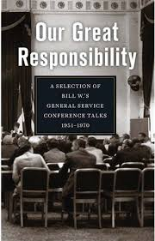
Each intolerant voice of AA is saying, “That’s the one, that group is the cancer that’s going to ruin it for everyone if we don’t stop them!” Will their outburst gain the intended result? How much of Gay Pride is born of homophobia? In AA, be it faction vs. faction or infighting within each faction, attempts to assert our will over the larger group may mobilize an opposite forces, “to maintain internal stability, owing to the coordinated response of its parts to any situation or stimulus that would tend to disturb its normal condition or function.”
Even within subcultures, AA’s singleness of purpose police don’t all agree on what the purpose is or how to achieve it. Will all freethinkers, atheists, humanists, agnostics, et al agree on what “secular AA” means? Some see a broader highway; some want to keep it pure.
Rebellion Dogs Publishing has talked/written about “the extraordinary liberties which the A.A. Traditions accord to the individual member and to [their] group,” but what does the average “My name is Joe” rank-and-file AA really know about their membership rights?
When I was new, I assumed that there must be a list of what is sacred and what is forbidden in AA. I saw similarities in the first 20 to 50 meetings I attended so I assumed they were following a list of rules that, although I hadn’t seen these rules, others had read them and agreed to what we had to do, and must not do, in our group.
And I heard people start sentences with, “In AA we always _______” or “In AA we never ________.” Did I challenge these members for evidence? No, I assumed they knew what was right. Rules seemed intuitive to me.
It seems counterintuitive that AA could run without any rules or penalties for failure to comply to said rules. I think that most members, even those starting their first meeting, haven’t read The A.A. Service Manual Combined With Twelve Concepts of World Service cover to cover. For starters, reading the service manual isn’t a rule.
Naturally, there is tribalism within AA; is it so bad if people claim they are members of the best group in the city? Be proud. This is the cultural determinism we enjoy in AA. But anytime you or I want to petition for more of our kind of AA and less of those stubborn and delusional AAs over there, we might not get what we bargain for.
How about those annual group and member numbers and some comparisons for context-sake?
A look at AA’s latest membership/group stats comparing to growth/decline since the start of the millennium. “World” refers to non-USA/Canada members and groups. If numbers don’t add up exactly, institutional (prison) and loner groups/members are not counted. “Survey says …”
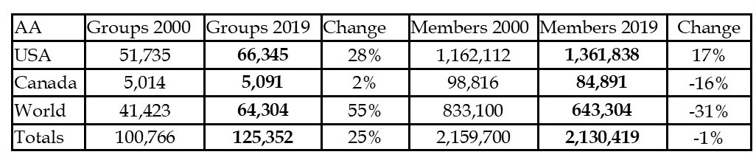
AA Membership worldwide is about the same over 19 years, while USA population has grown 16%. American AA has increased 17%, about the same as the country, adding just under 200,000 American AA members.
Everywhere else, AA is in decline. Canada has 16% fewer members and non-USA/Canada members is -31% over 19 years. This makes AA a more American-centric fellowship that two decades ago.
Canada has lost almost 14,000 members. Outside USA/Canada members have fallen off 189,796 members.
And while membership totals stays the same, we are dividing up into more, smaller group. AA added 25,000 more groups over 19 years while having about 30,000 fewer members. We may want to resist putting too much of own biased meaning into why these numbers are what they are. Fundamentalists, Relativists and Traditionalists may all want to blame the others for AA’s declining populations compared to world population growth. Again, is “We need more of my kind of meetings and less of that one over there,” going to help?
Online members and groups are not counted in this comparison.

https://www.facebook.com/groups/246417729261168/
https://www.aa.org/newsletters/en_US/en_box459_spring19.pdf
AAWS, Our Great Responsibility: A Selection of Bill W.’s General Service Conference Talks 1951—1970, New York: 2019
Special Report for the Groups on the THIRD GENERAL SERVICE CONFERENCE of A.A. p. 22
https://www.aa.org/assets/en_US/en_bm-31.pdf
https://www.asanet.org/sites/default/files/savvy/introtosociology/Documents/Glossary.html
Kurtz, Ernest, Not God: A History of Alcoholics Anonymous, Note 67

